# Project 2 README

## About the Project/Project Title

This is a database and interface project for Grazioso Salvare, a company that trains rescue animals. This project cross references data from the Austin Animal Shelter listings with preset searches that meet different criteria provided by Grazioso.

## Motivation

The motivation behind this project is to streamline the searching portion of Grazioso’s training program. The user can simply click what type of rescue scenario they need to train for, and the table and widgets will populate with results.

## Getting Started

**Creating a user**: Using the admin account, you can create a user(s) with different permissions as needed. This can be done in the mongo shell by typing “mongosh” in the terminal.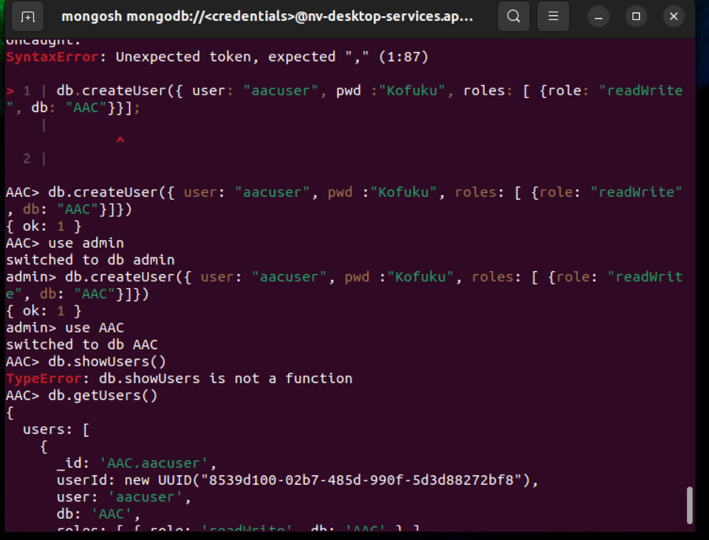

**Creating new documents:** The following example code shows a Jupyter test file creating a new test pet entry. This is done with JSON formatted key value pairs and then inserted into the database.

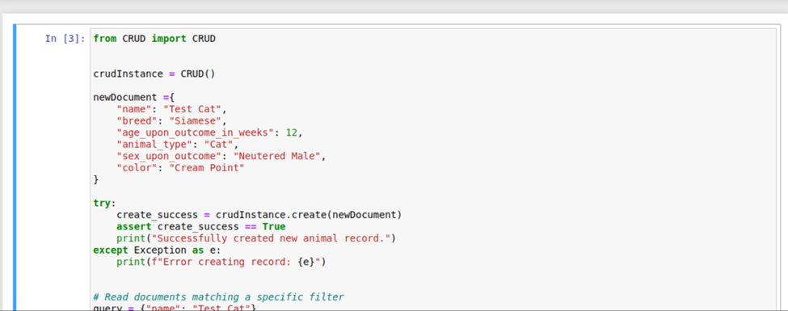As you can see in the next example, running this multiple times will create duplicate entries in the database. Be mindful to clean up unintended entries.

**Searching the database:** The top of the below image shows sending a query that

filters the results to the parameters inserted. The second image shows searching for dogs via the dashboard search.

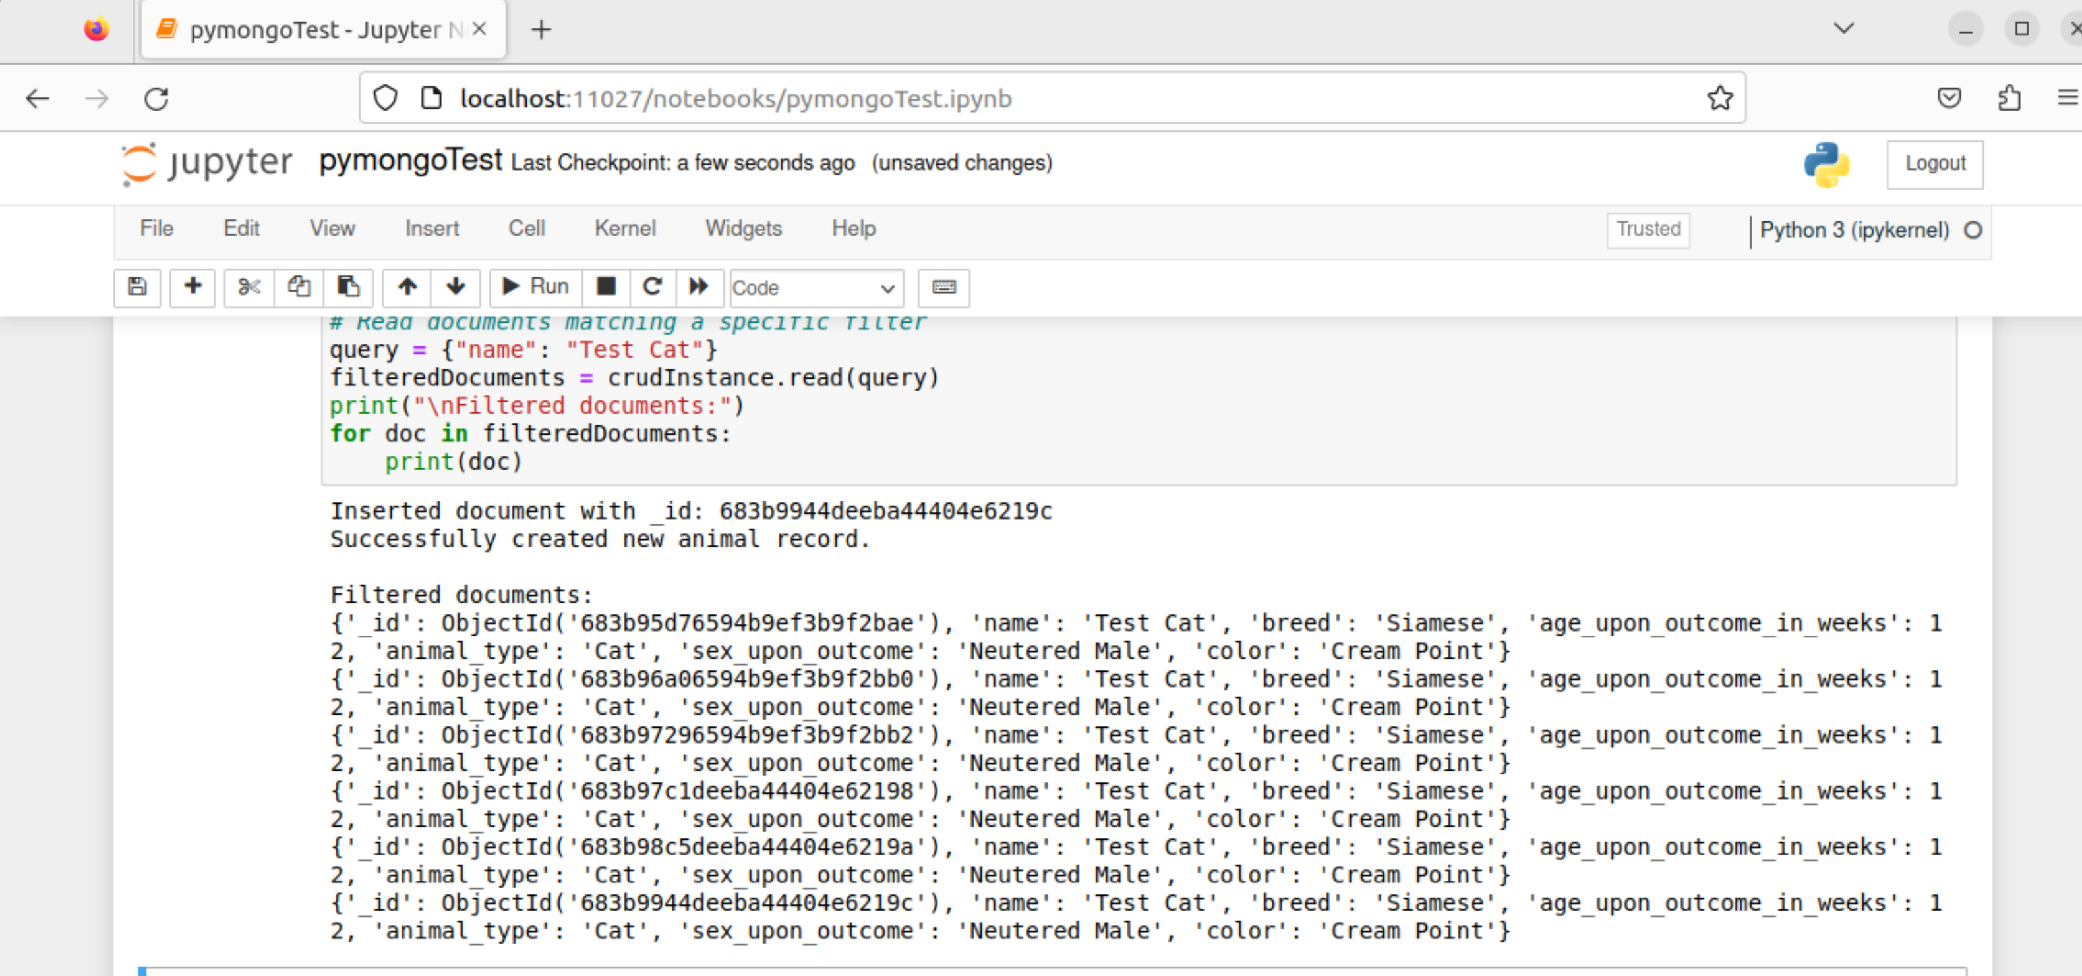

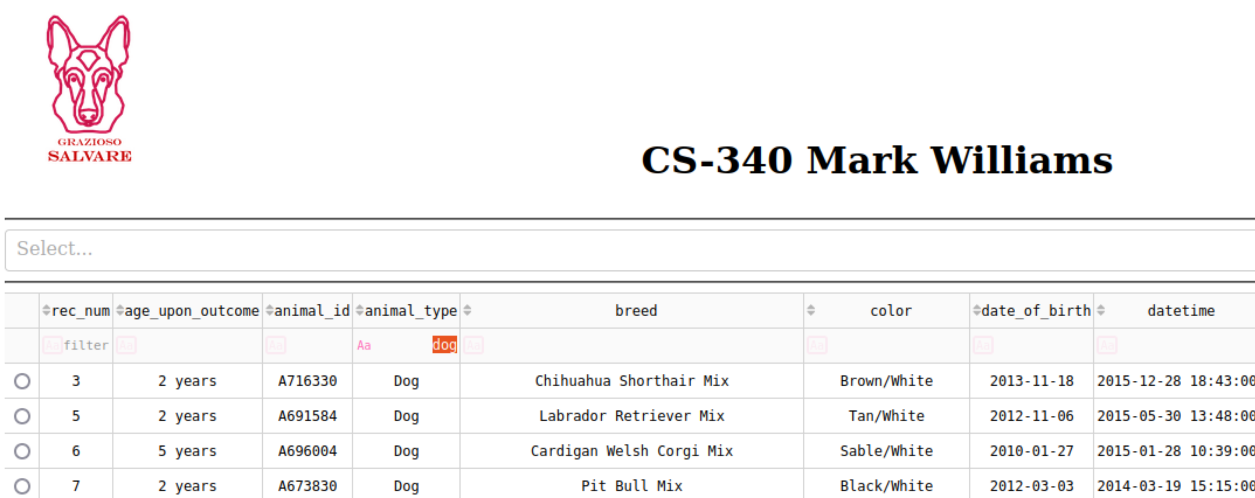

**Updating or deleting a document:**

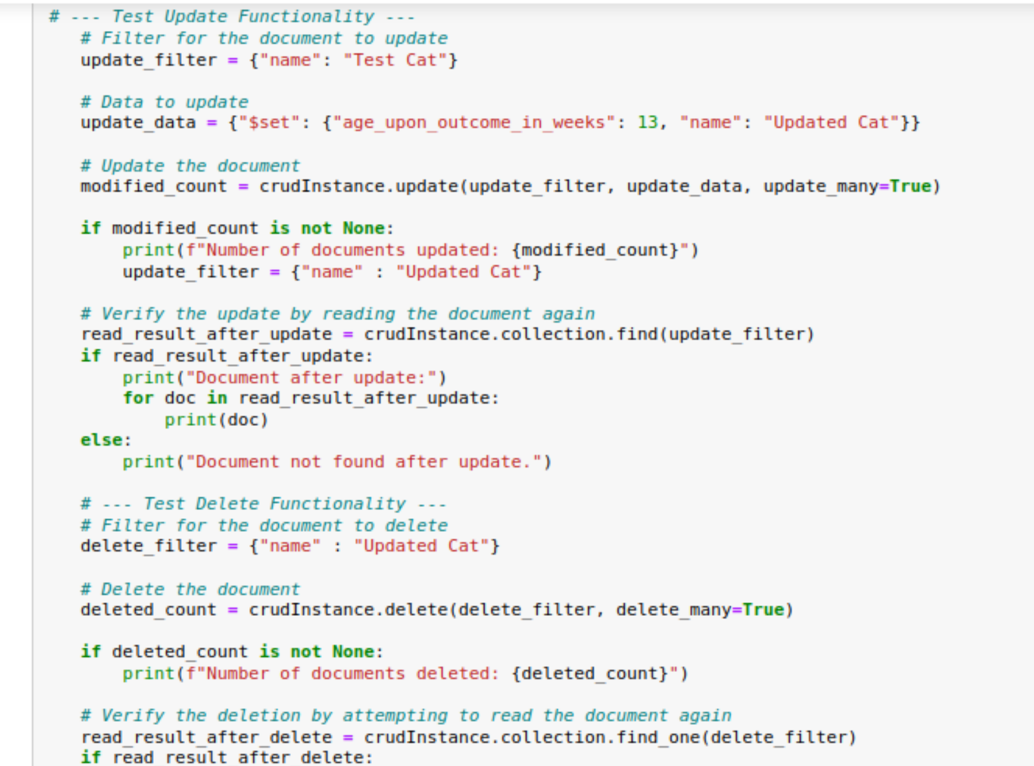

## Installation

For this setup you will want to ideally run a Linux terminal and install MongoDB along with this application, including the Python drivers. PyMongo is an included communication medium between Python and MongoDB. Jupyter notebook is also recommended for testing purposes.

## Usage

Using this application, you can find matching entries with any attribute or combination of them. With the dashboard, you can sort and search by any attribute or use the drop-down menu to select specified rescue search queries.

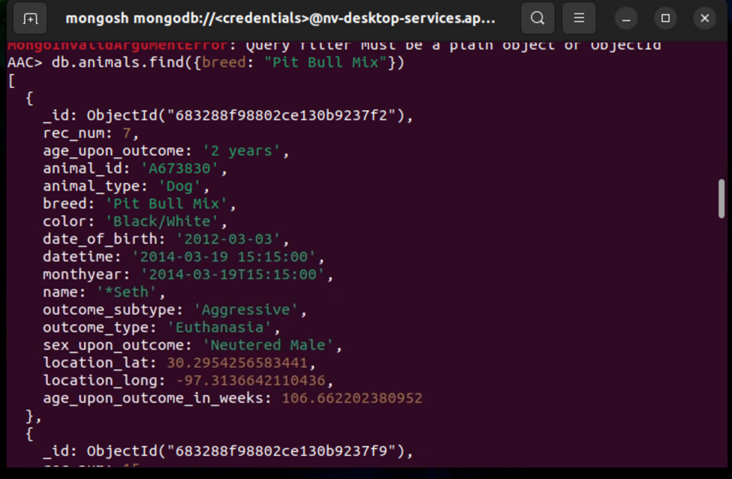

**Code Example**

### Initializing the authentication information in the python module, you would fill this with your own information if it differs from the example.

*

### This example shows the dash set up for the drop-down menu.

### Tests

The following screenshots display the drop-down menu results on the table and widgets for each rescue search.

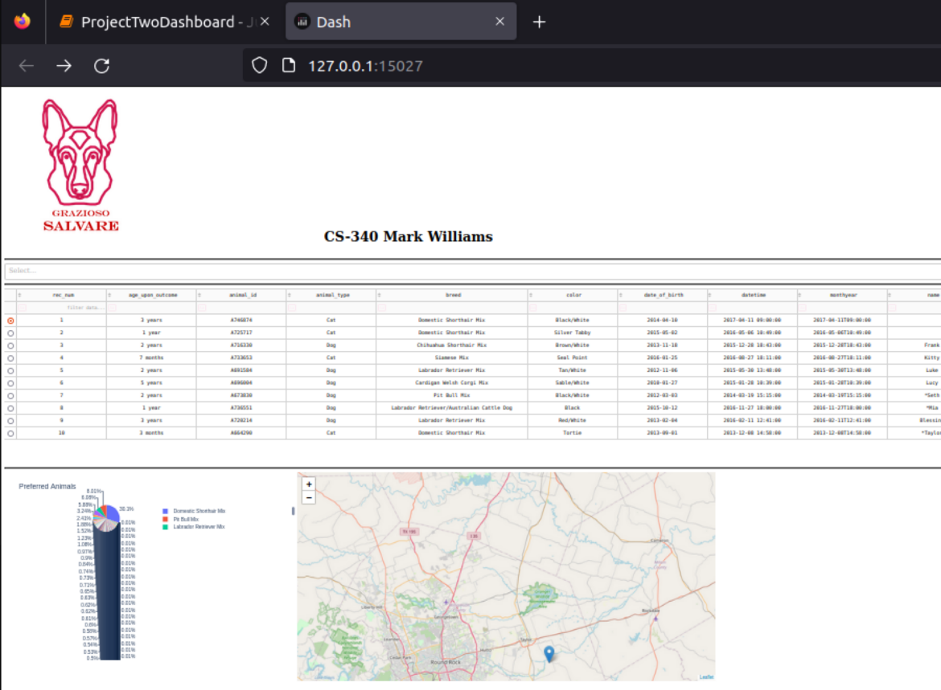

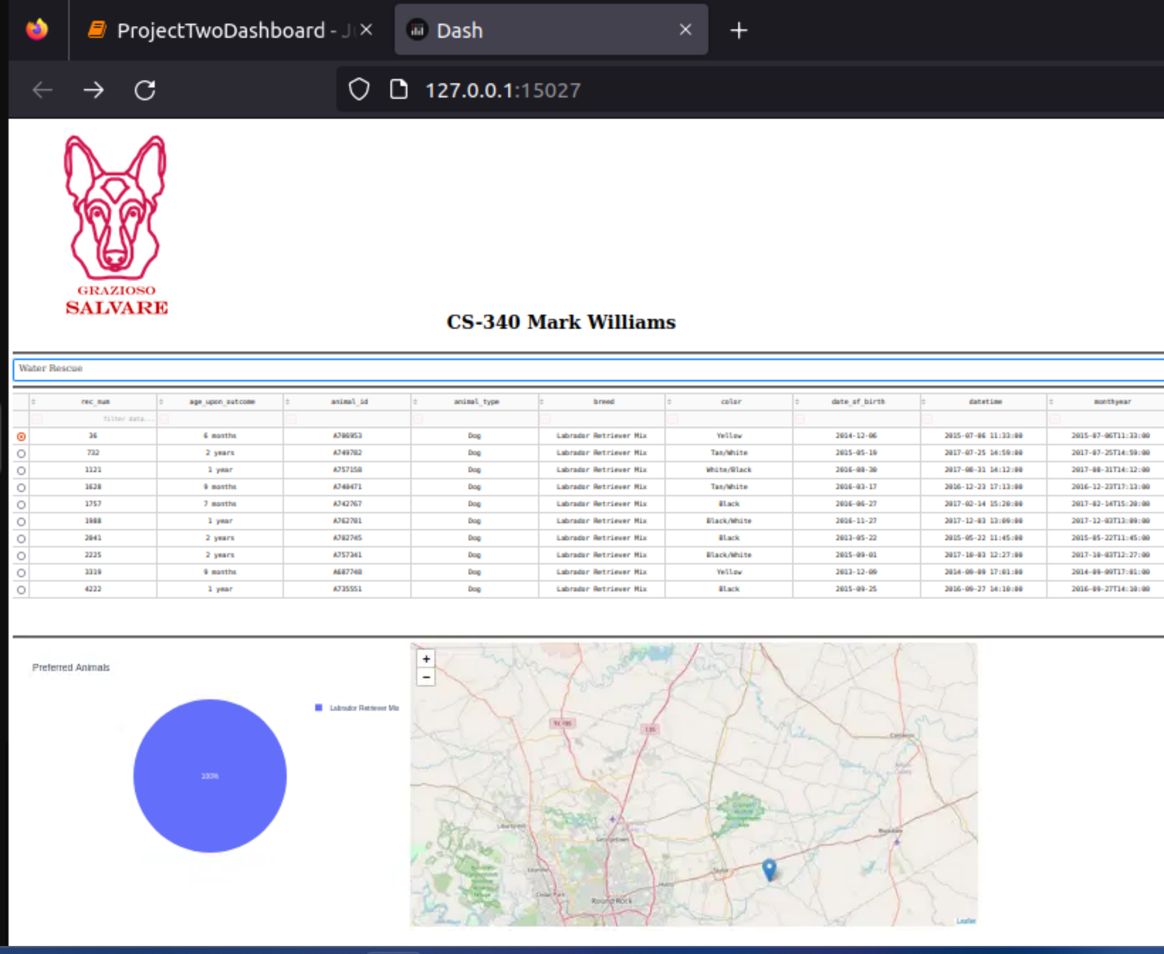

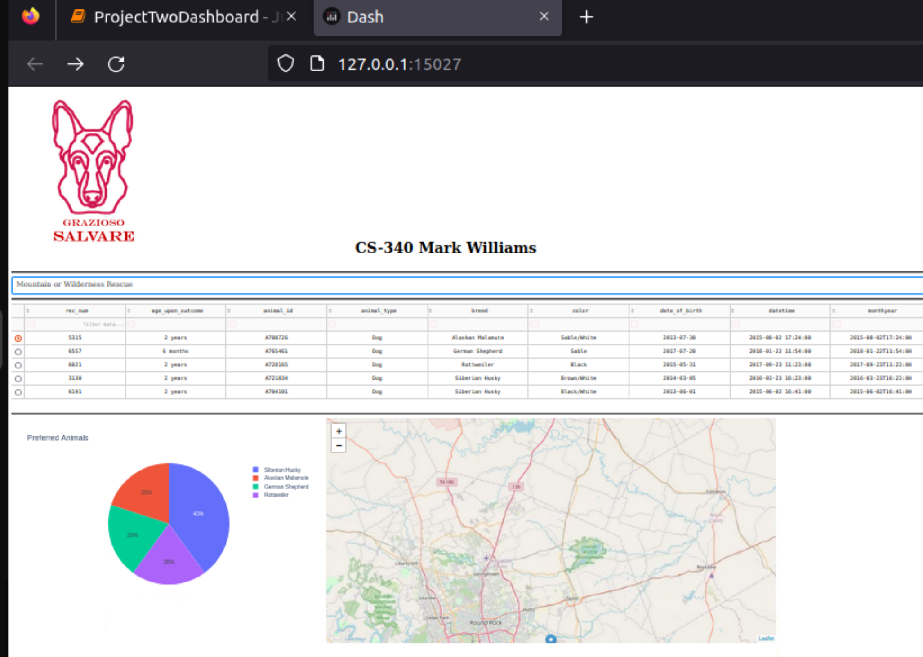

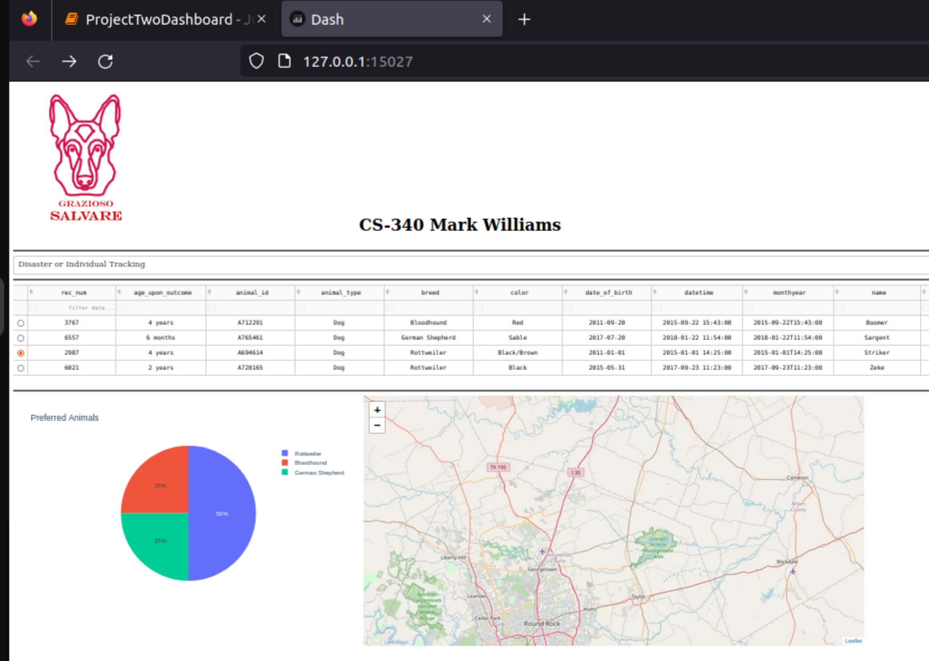

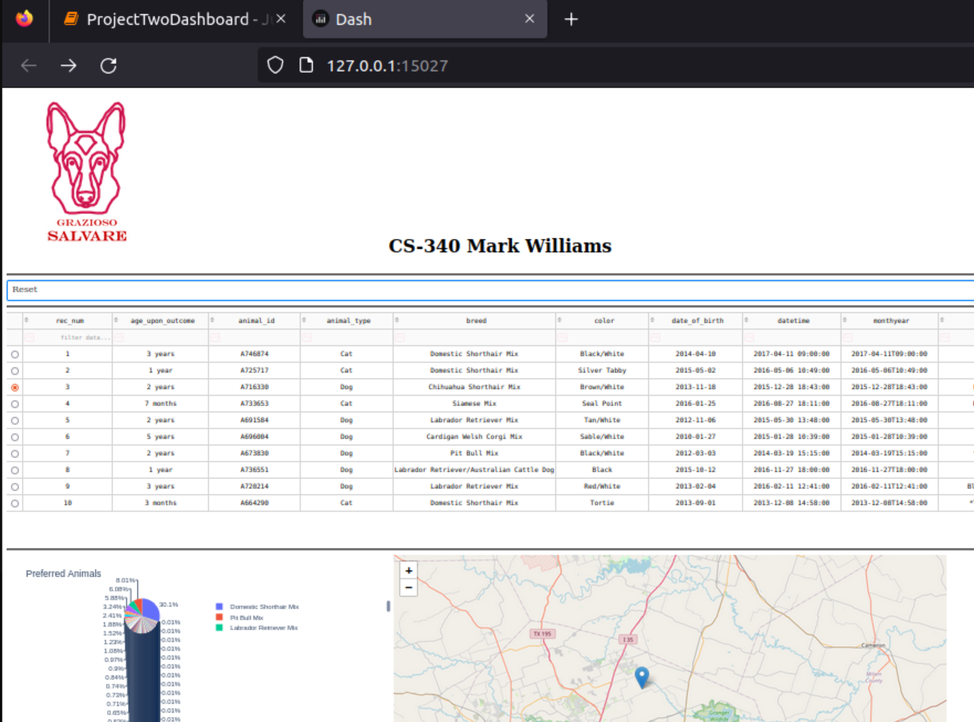

## Contact:

Mark Williams